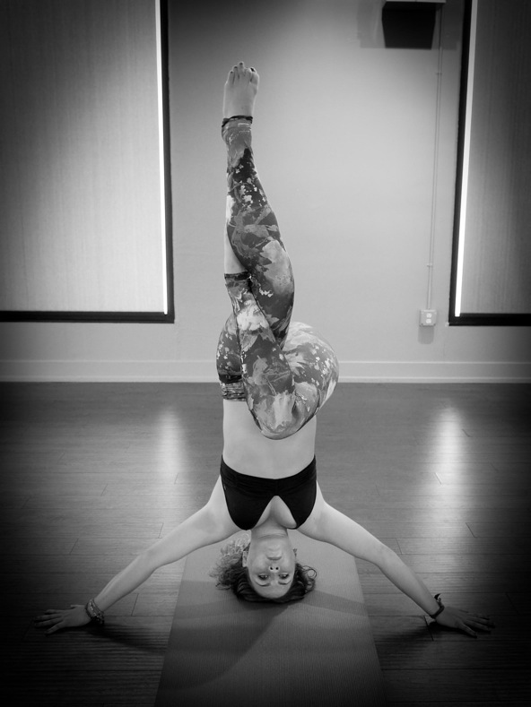

Hello my name is Kelly Linehan and I am going to be a senior at CU Boulder. I received my certification in spring 2014 at CorePower Yoga in Boulder and I have been employed at Sumits Yoga Marin since. I am returning to Colorado this summer for an internship and looking to continue teaching. My other internship is M-F from 10am to 4pm so I am available at all other times. This position would fit perfectly into my schedule and hopefully it could continue throughout the next school year. The Sumits studio is a very upbeat strength-conditioning style of yoga, and I have a good balance of knowing when to push my students and let them surrender and I also do very well at picking the perfect music and cues to help my students find that balance of when to pump it up and when to slow it down. Since Sumits is located in California, I only teach when ever I return home for breaks and for the summer, so I am really miss not being able to teach all year round. Any opportunity to expand as a teacher I am open to. My email and phone number are provided at the top.

**Certification and Skills**

* + - * **Graduate of CorePower’s 200 hour Hot/HotPower Fusion teacher training April 2014**

## **Completed CorePower’s Extensions Program.** **May 2014**

* Registered (RTY) with the Yoga Alliance
* Labiality insurance
* Have Practiced Vinyasa , Hatha, Ashtanga , Bikram , Iyengar and Restorative.

**Instructor at Sumits Yoga Summer 2014- present**

Reference: Darlene Arnal, Instructor and Studio Owner, (415) 613-2727, darlene@sumitsyogamarin.com

* Creatively sequence my own classes, using a blend of Bikram balancing poses, Vinyasa flows, and strength conditioning(push ups, situps ,leg drops, etc) , or follow Sumits traditional sequence ( 80 minute and 60 minute sequence)
* Over 100 plus hours under my belt
* Very familiar with MindBodyOnline
* Control heat and humidifiers
* Love doing hands on adjustments
* Create a unique music playlist for every class to keep it fresh
* Prepare a new intention or opening for every class to always have my students coming into the room ready for something different everyday.
* Clean and prepare the studio and room before each of my classes.

**Alignment and foundations yoga workshop at Summits Yoga August 3rd ,2014**

* Taught and sequenced my own 2 hour workshop that focuses on alignment and the foundations of basic yoga poses for students to expand their practice
* Had 40 participates total

**Education**

## **University of Colorado at Boulder August 2012 – May 2016**

* Major: Communications
* Minor: Technology , Arts and Media (the TAM school)

**Apology:**

An apology is an expression of remorse. An apology is a commutative action take acceptance for their wrongdoing. People always make mistakes, its **>> '**apparent of human nature. When people understand their wrong doing it is often followed by an apology. We try to fix something that we broke. **>> How do Tracy and Robles define apologizing?**However, when people are in the public eye mistakes made headline news and an apology is always expected. Cheating has almost become cultural gender normative **>> Unclear, explain.**, yet this issue is very gender identified almost always males being the wrong doers. **>> What evidence do you have to back up this claim?**I think something that is interesting is that since infidelity is such a private manor that deserves to be dealt with in that manor **>> sp**. However, when someone is in the public eye, private manors are abolished and they not other hurt people they are intimately close with but public. **>> Unclear.**As a public we try to make sense of these things, either it be personal or public. The article I believe exemplifies this concept was, The Art of the Public Apology. This article provides multiple examples **of**how apologies can function as often a game of blaming. Rambling, self-pity, beyond the point of help, or falsehood **>> Are these aspects or characteristics of apologies addressed in the data? Explain.**these apologies were all on personal matters but had to be address publically because people rely on public trust. **>> What do you mean? What is public trust and why is it important/maintained through apology?**The comedians, athletes, and actors all symbolize public trust because you came to be a fan based on who you perceived them to be the public trust is invalid. **>> Unclear. Explain.**In Tiger Woods **>> '**apology he stated "I had affairs, I cheated. What I did was not acceptable, and I am the only person to blame." This data illustrates the different forms **>> What forms are you referring to? What forms are evident here?**one uses to apologize, but on a public scale.

<http://www.nytimes.com/2010/02/21/weekinreview/21vitello.html?_r=0>

Tracy and Robles define an apology as an attempt to split off the current good self from the bad self and an acknowledgement that one’s action was bad (87).From my personal experience, I believe that most cheating scandals are committed by men in the public eye; Bill Clinton, Jesse James, Brad Pritt, Arnold Schwarzenegger , etc .(<http://www.hollywood.com/general/20-famous-celebrity-cheating-scandals-60109173/#/ms-8281/14>) In the article, it talked about the art of the public apology with examples like Rambling, self-pity, a game of blaming. The characteristics expressed are provided with different case examples; I am not familiar with some of the case’s so here is an expert:

“

A “Mark Sanford,” for example, is the sort of rambling, confessional apology that leaves you worse off than before. A “Mark McGwire” is the self-pitying apology that shows a lack of genuine contrition, and broadcasts your resentment at being caught. The dread “John Edwards” is that apology which almost does not matter because you are for the foreseeable future beyond help.”

Public trust is automatically installed in you when you are in the public eye. The public trusts you as a celebrity as someone they can spend their money on, let their kids look up to etc. So when people in the public eye do something bad, an apology is expected because they have to restore that public trust or else their lifestyle can no longer continue and the public will no longer pay attention to them. In Tiger Wood’s apology he was upfront and owned up to his actions instead of using the blame game, or rambling. So he wasn’t using any of the forms I was referring to.

**Gossiping** is a face threatening speech act that involves speaking, usually negative **> Gossip is often not negative, though the fact that it happens behind a person's back is what makes it face threatening..**about someone. **>> When that person is not present.**I found this topic very interesting to read about because we all gossip. It function**s** as a way to pass information about others or keep us in the loop **>> Apart from sharing information, what other functions does gossiping serve?**, which can be negative or positive. In the article, Keep Up The Gossip, It Makes us Human. This article presents the option that gossiping expands your social network. **>> How so?**I think this article relates to the topic because it digs deeper than the definition. Gossiping is not always negative, but it does give participants a wider social circle learning about others. **>> How so?**

Gossip can also function as a way to save your own face and a way to make conversation. If you are gossiping about someone else you can be trying to save your own face by making yourself look better and it can also just be a way to extend or promote conversation with someone you don’t really know that well. This is what the article is claiming; that gossip can function as a conversation and social extender, because you make more conversation with others and you know more about others. This creates a loop because if you know something about someone through gossip you can bring it up to that person which can extend your conversation. Than that gossip and information gathered from that conversation can then be transferred and used to another so it creates a loop.

http://www.calgaryherald.com/life/relationships/Keep+gossip+makes+human/11138080/story.html

**Identity Work**: Identity work is the process through which talk makes available to participants and observers who the people doing the talking must be. **>> Partial quotes require quotation marks and citations, otherwise they are plagiarized.**This concept has two sides: First is that talk dos **>> Proofreading**does identity work. Through a persons **>> ' See**[**http://theoatmeal.com/comics/apostrophe**](http://theoatmeal.com/comics/apostrophe)**for a quick and amusing overview of apostrophe usage.**choices how to talk identity work is accomplished. It represents people’s ways of talking construct pictures of who people must be. The other side is that peoples **>> '**preexisting identifies (age, nationality, profession) work to shape how they will talk. Identity work is a crucial part of everyday interaction that has to do with the views of self and other that are being built up and reflected in talk. Talk does identity work, it presents who people are and it alter casts the partner. Currently many people are announcing their interest to run for presidency. I found it interesting that many candidates construct their identity rather than just use that to identity what they believe in. For example, Donald trump has made the head lines recently because after his announcing running to the president his identity work shifted from being a real-estate mogul, to a conservative identity. **>> How did he communicate these aspects of ID? Where do you see the shift take place?**

We all remember when the Apprentice first hit the air and Donald trump was known as a real-estate mogul with a bad toupee, but now he has shifted into politics and he communicates his political views that identities him with a certain political party. For example, his views on immigration have been widely publicized in the recent months; with this communication it is clear his political affiliation without communicated it to the public.

http://theweek.com/articles/560942/donald-trump-personification-republican

<http://prospect.org/article/all-politics-identity-politics-0>